**FU BBKH 3.20.2 Operating conditions Catalyst heating BDE**

FDEF BBKH 3.20.2 function definition

Overview

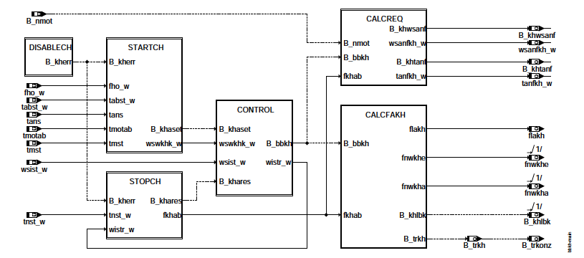

**bbkh-main**

Block STARCH: Switch-on condition for catalytic converters

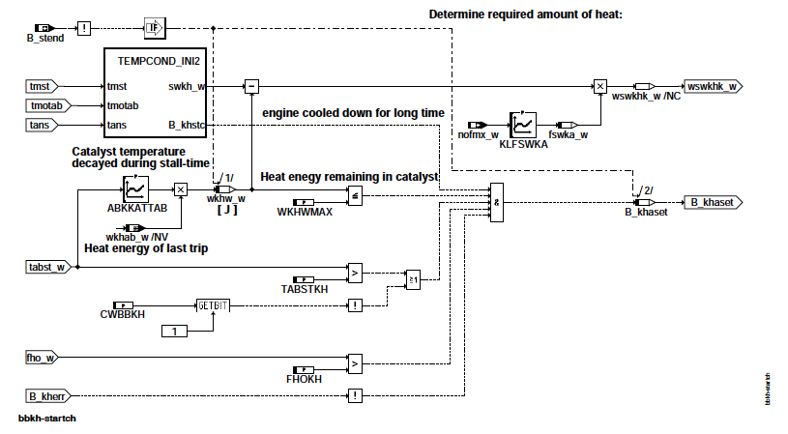

bbkh-startch

Block TREMPCOND: Detection of sufficient cooling

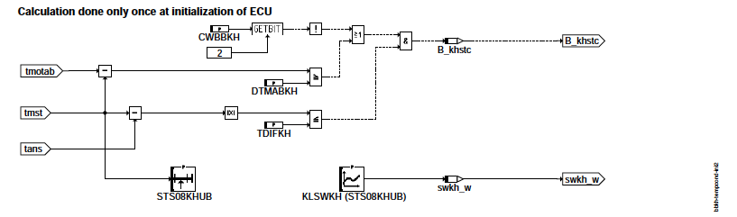

bbkh-tempcond-ini2

Block STOP: Stop and stop conditions of catalytic converters

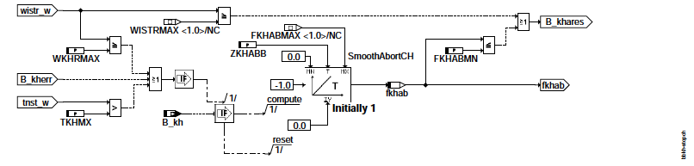

bbkh-stopch

Block DISABLECH: Errors leading to the cancellation of catalytic cylinders after start

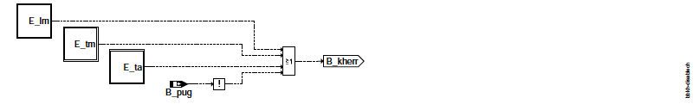

bbkh-disablech



bbkh-control

Block CALCREQ: Determination of the current requirements for catalytic converter

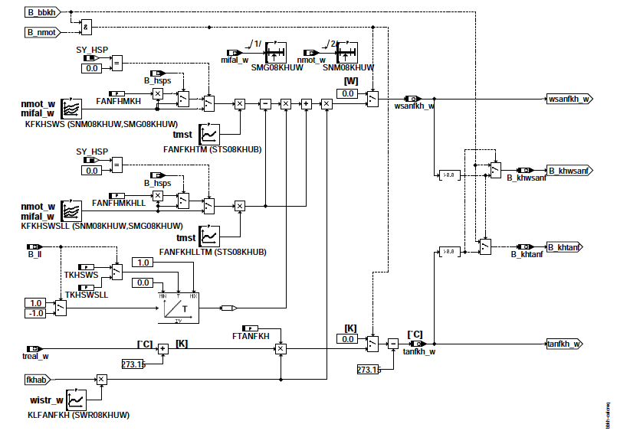

bbkh-calcreq

Block CALCFAKH: Calculation of the control factors flakh, fnwkhe and fnwkha

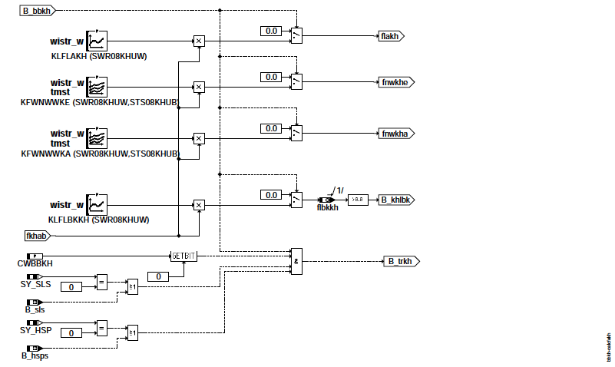

bbkh-calcfakh

initialization



bbkh-initialize

Initializations in block STARCH

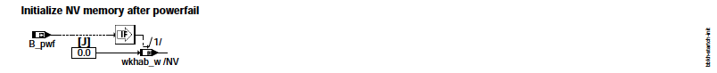

bbkh-startch-init

Initializations in the BLOCK STOP

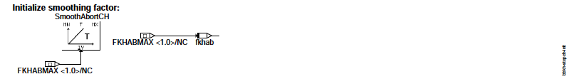

bbkh-stopch-init

**ABK BBKH 3.20.2 Abbreviations**

|  |  |  |  |  |
| --- | --- | --- | --- | --- |
| Parameter | Source-X | Source-Y | Type Name | Description |
| ABKKATTAB | TABST_W |  | KL | Cooling curve as a function of the shutdown time |
| CWBBKH |  |  | FW | Codeword: Switch-on conditions Cat. After start |
| DTMABKH |  |  | FW | Temperature difference between switch off and restart for release Cat |
| FANFHMKH |  |  | FW | Reduction factor for cathexis requirements for hom. Simple injection |
| FANFHMKHLL |  |  | FW | Reduction factor for heat catalyzing in LL at hom. |
| FANFKHLLTM | TMST |  | KL | weighting Heating requirement for catalytic heaters after start over engine start temp. (LL only) |
| FANFKHTM | TMST |  | KL | weighting Heating requirement for catalytic heaters after start over engine start temp. |
| FHOKH |  |  | FW | minimum height factor for catalytic cylinders |
| FKHABMN |  |  | FW | Threshold reduction factor for catalytic heating |
| FTANFKH |  |  | FW | Proportion of treal_w as temperature demand Exhaust gas for heating the catalytic converter after start |

|  |  |  |  |  |
| --- | --- | --- | --- | --- |
| KFKHSWS | NMOT_W | MIFAL_W | KF | Characteristic Demand heat flow in the exhaust gas for catalytic heaters after start |
| KFKHSWSLL | nmot_w | MIFAL_W | KF | map request (in the LL) f ¨ W ur lean stream in the exhaust ¨ f ur Kat-heating after start |
| KFWNWWKA | WISTR_W | MST | KF | Weighting chart for NW nominal angle on outlet side |
| KFWNWWKE | WISTR_W | TMST | KF | Weighting chart for NW nominal angle on inlet side |
| KLFANFKH | WISTR_W |  | KL | weighting factor f ¨ ur requirements for catalyst heating (wsanfkh_w, tanfkh_w) |
| KLFLAKH | WISTR_W |  | KL | Weighting factor for lambda control factor flakh for catalytic heaters |
| KLFLBKKH | WISTR_W |  | KL | Specification of the control factor flbkkh for LBK position for catalytic heaters |
| KLFSWKA | NOFMX_W |  | KL | Specification factor "target heat" depending on the catalysis |
| KLSWKH | TMST |  | KL | Characteristic setpoint heating for heating the catalytic converter after engine start |
| SMG08KHUW | MIFAL_W |  | SV | ST utzstellenverteilung ¨ f ur torque demand for transmission protection (miglsol_w) |
| SNM08KHUW | NMOT_W |  | SV | SST distribution for LAKH speed |
| STS08KHUB | TMST |  | SV | Stations Distribution for Engine Start Temperature (tmst) |
| SWR08KHUW | WISTR_W |  | SV | ST utzstellenverteilung ¨ f ur Katheizfortschritt (wsistr_w) |
| TABSTKH |  |  | FW | Minimum storage time for release of catalytic converter heating |
| TDIFKH |  |  | FW | Minimum absolute temperature difference (tans - tmst) for Recognition Recognition |
| TKHMX |  |  | FW | Maximum duty cycle of the Catalyst function |
| TKHSWS |  |  | FW | transition time for heat flow demand: from LL to load demand |
| TKHSWSLL |  |  | FW | Transition time for heat flow demand: from load to LL demand |
| WKHRMAX |  |  | FW | Maximum relative heating progress Cathexis for initiating reduction |
| WKHWMAX |  |  | FW | Maximum heating power for catalytic cylinders after restart |
| ZKHABB |  |  | FW | Time constant for demolition low pass cathe- factories |

|  |  |  |
| --- | --- | --- |
| System constant | Type | Description |
| SY_HSP SYS | (REF) | System Constant BDE Mode Homogeneous Split (HSP) |
| SY_LBK SYS | (REF) | System constant for the LBK |
| SY_NWS SYS | (REF) | System constant camshaft control: none, 2-pt. or steadily |
| SY_NWSA SYS | (REF) | System constant camshaft control Outlet side: none, 2nd point, cont. |
| SY_SLS SYS | (REF) | System constant secondary air pump present |

|  |  |  |  |  |
| --- | --- | --- | --- | --- |
| Variable | Source | Referenced by | Type | Description |
| B_BBKH | BBKH |  | LOK | Condition: Requirements for catalytic heating after start are provided |
| B_HSPS | BDEMKO | AWEA, BBKH, BDEMUS, KOMRH, LAKH, ... | ON | condition Homing split mode |
| B_KH | BAKH | BBKH, BBSAWE,BDEMAB, BGFAWU, BGNLLKH, ... | ON | condition Kat heater |
| B_KHASET | BBKH |  | LOK | Condition Set bit B_kha |
| B_KHLBK | BBKH | LBKSOL | OFF | Condition: Setpoint of the LBK for catalytic heaters |
| B_KHSTC | BBKH |  | LOK | Dependent on temperatures or shutdown time. Catalyst heating |
| B_KHTANF | BBKH | BAKH, BBKW | OFF | Condition exhaust gas temperature required to heat the catalyst |
| B_KHWSANF | BBKH | BAKH, BBKW | OFF | Condition exhaust gas flow requested to heat the catalyst |
| B_LL | MDFAW | ARMD, BAKH, BBAGR,BBAGRMW, BBKH, ... | ON | condition idle |
| B_NMOT | BGWNE | ADVE, AEKP, ALE, ALSU, BAKH, ... | ON | condition engine speed: n> NMIN |
| B_PUG | GGDSU | BBKH, BGDSAD, TVWNO | ON | Condition Ambient pressure is valid |
| B_PWF | BBHWONOF | ABKVP, ADAGRLS, BBBO, BBKH, BDEMUM, ... | ON | condition Powerfail |
| B_SLS |  | ATM, BBAGR, BBKH, BGLAMBDA, DKATFKEB, ... | ON | condition Secondary air active |
| B_STEND | BBSTT | ADAGRLS, ADVE, AEKP, ALE, AMSV, ... | ON | condition starting reached |
| B_TRKH | BBKH | LLRRM | OFF | Catalytic condition, thermoreactor effective |
| B_TRKONZ | BBKH | BGTPABG | OFF | Condition that catalyzing with a thermoreactor concept is realized |
| DFP_LM | BBKH | ATR, BBAGR, BBKH, BGRLFGZS, DDSS, … | DOK | SG int. Fault Path No.: Master Load Sensor |
| DFP_TA | BBKH | ATR, BBAGR, BBKH, BGAGRTS, BGTMPK, ... | DOK | SG-int. Error path number: intake air temperature TANS (-Ladeluft) |
| DFP_TM | BBKH | ATM, ATR, BBAGR, BBKH, BGTABST, ... | DOK | Internal error path number: Motor temperature |
| E_LM | DSELHFS | ATR, BBAGR, BBKH, BBKW, BGRLFGZS, ... | ON | Errorflag: main load sensor |
| E_TA | GGTFA | ATR, BBAGR, BBKH, BBKW, BGAGRTS, ... | ON | Errorflag: intake air temperature |
| E_TM | GGTFM | ATM, ATR, BBAGR, BBKH, BBKW, ... | ON | Error flag: TMOT |
| FHO_W | GGDSU | BBKH, BBNWS, BGNLLKH, BGRLMXS,BGRLSOL, ... | ON | correction factor (word |
| FKHAB | BBKH |  | LOK | Factor catalytic converter heating for reduction |
| FLAKH | BBKH | LAKH | OFF | Factor lambda control for catalytic heaters |
| FLBKKH | BBKH |  | OFF | Factor LBK control for catalytic heaters |
| FNWKHA | BBKH | BBNWS | OFF | Weighting factor for camshaft setpoint angle for cathe- factories (outlet) |
| FNWKHE | BBKH | BBNWS, NWSOLLE | OFF | Weighting factor for camshaft setpoint angle for catalysis (inlet) |
| FSWKA_W | BBKH |  | LOK | Factor nominal heat depending on the catalysis |

|  |  |  |  |  |
| --- | --- | --- | --- | --- |
| Variable | Source | Referenced by | Type | Description |
| MIFAL_W | MDFAW | BBKH, BDEMEN, KOMRH, KOS, MDKOL, | On | Indexed Driver Desired Moment for Moment Coordination Filling |
| ... |  |  |  |  |
| NMOT_W | BGNMOT AEVABU, AGRUE, ALE, AMSV, ARMD, ... |  | ON | engine speed |
| NOFMX_W | SKR | BBKH | ON | Upper adaptive limit fictitious NOx raw mass flow |
| SWKH_W | BBKH |  | LOK | Nominal heat for catalysing at engine start (16-bit value) |
| TABST_W | BGTABST | AEKP, BBKH, BDEMUM, BGTOL, BGTPABG, ... | ON | shutdown time |
| TANFKH_W | BBKH | KODOH, KOMRH | OFF | Required exhaust gas temperature during catalyst heating after start |
| TANS | GGTFA |  | ADAGRLS, ADVE, ATEV, ATR, BBKH, ... | ON |
| TMOTAB | GGTFM | AEKP, BBKH, BGTABST, BGTOL, DLSF, ... | ON | engine temperature when parking |
| TMST | GGTFM | BAKH, BBAGR, BBBO, BBKH, BBSAWE, ... | ON | engine start temperature |
| TNST_W | BBSTT | ABKVP, BBDNWS, BBKH, BBNWS, BBSAWE, ... | ON | time after the start |
| TREAL_W | BAKH | BBHTRIP, BBKH, BBKW, BGSIK | ON | realizable exhaust gas temperature in current BDE mode |
| WISTR_W | BBKH | BGNLLKH, LAKH | OFF | Relative heating progress for catalytic converter since engine start |
| WIST_W | BBKH |  | LOK | Exhaust-generated heating heat for catalyst since engine start |
| WKHAB_W | BBKH |  | LOK | Permanent RAM: Heating in the catalytic converter at the end of the last trip |
| WKHW_W | BBKH |  | LOK | Continuous RAM: Heating power for catalytic converters from local engines |
| WSANFKH_W | BBKH | KODOH, KOMRH | OFF | Total thermal exhaust gas flow while heating the catalyst after start |
| WSIST_W | BAKH | BBKH | ON | actual exhaust gas flow |

**FB BBKH 3.20.2 function Description**

The catalytic heater function determines the conditions for the accelerated heating of the catalytic converter after starting the engine. she decides the specifications for:

- BAKH: Conditions for requesting desired heat flow and / or setpoint temperature in the exhaust gas (B_wsanfkh, B_tanfkh)

- KODOH / KOMRH: desired heat flow and setpoint temperature in the exhaust gas, coordination takes place in BAKH (wsanfkh_w, tanfkh_w),

Error Conditions, Graphical Hierarchy DISABLECH:

The graphical hierarchy DISABLECH is used to summarize error conditions that generally block cathexis. This are mainly the errors of the evaluated signals (intake air temperature, engine temperature and altitude signal). In addition becomes Cathexis blocked on a faulty load signal (E_lm).

Switch-on condition, graphic hierarchy START:

The graphical hierarchy STARTCH determines the switch-on condition (B_khaset) as well as the necessary heat quantity (wswkhk_w) for catalytic heating.

The engine and ambient temperature in TEMPCOND_INI2 are evaluated as soon as the ignition is switched on. It will be checked if this keep temperatures close to a sufficiently long shutdown time (or cooling time). Only in this case (B_khstc = true) will catalytic converter heating unlocked. B_khstc is characterized by a small temperature difference between intake air tans and engine start temperature tst at start (| tans - tmst | <= TDIFKH). By setting bit 2 in CWBBKH, you can add a minimum Engine cooling (tmotab - tmst> = DTMABKH) are required.

With KLSWKH, the heat quantity swkh_w is determined from the engine temperature and, with a very long shutdown time, it is used for catalysing would be necessary.

In order to avoid overheating of the catalytic converter by several repeat starts, in the last engine run the enforced Heat accumulated in wkhab_w. With the ABKKATTAB cooling curve, this amount of heat becomes the remaining one over the shutdown time

Heat quantity wkhw_w determined. If this heat quantity from previous engine starts (wkhw_w) exceeds the threshold WKHWMAX, then a prevents renewed catalysis. Otherwise the still necessary heating heat wswkhk_w = swkh_w - wkhw_w is required.

In addition, depending on the catalysis, the necessary heating heat (and therefore the heating time) can be generated via the characteristic curve KLFSWKA. be extended. As a result, the system behaviour can slowly change over the learned aging factor. The influence of this behaviour on emissions must be assessed.

Example: Catalytic heating is continuously extended by aged cat. As a result, but exhaust gas mass flow and raw emissions increased, which in the long term can increase the final emissions.

Until the end of the engine start, further switch-on conditions are checked:

- Minimum Height Compensation Factor (fho> FHOKH)

- Minimum stop time (tabst_w> TABSTKH) if bit 1 of CWBBKH is set

- no blocking conditions set

Off condition, graphic hierarchy STOP:

The requirement for catalytic heating is cancelled (B_khares = true), if the engine minimum speed is exceeded (B_nmot = false) or the maximum relative heating progress WISTRMAX = 0.9999 is reached.

If a relevant error occurs (B_kherr = true) or if the heating process is already well advanced (tnst_w> TKHMX or wistr_w> = WKHRMAX) an abort of the K catalytic converter heating is initiated. In this case, the reduction factor fkhab sounds with the time constant ZKHABB

from 1 to 0 If the value falls below the threshold fkhab <= FKHABMN, the request for cathexis is withdrawn. Also a crossing the time limit tnst_w> TKHMX leads to termination. An interruption of the catalytic converter heating can also out by the error conditions DISABLECH be initiated.

Conditions:

The hierarchy CONTROL determines the relative heating progress wistr_w from the achieved heat flow wsist_w. over the group distribution SWR08KHUW can be weighted most needs.

If no heat is required, or if catalysis is aborted via B_khares, then B_bbkh is withdrawn. This is the heating requirements deleted.

The graphic hierarchy CALCREQ determines the requirements for heat flow from induced engine nominal torque mifal_w and engine speed wsanfkh_w and temperature tanfkh_w in the exhaust. The temperature requirement is z. Currently only for testing purposes, the condition should therefore always be FTANFKH = 0!

The heating requirements depend on the engine speed. Therefore, a speed signal must first be present (B_nmot = true), so the heating requirements can be released. As long as the operating conditions for catalytic heating have been reached (B_bbkh = true),

but no speed signal is present, only the request bits B_khwsanf and B_khtanf are set.

For the heat flow demand, a distinction can be made between no-load (KFKHSWSLL) and load (KFKHSWS). When leaving idle is switched within TKHSWS seconds, at start idle within TKHWSWLL seconds. Both demands can still be heard

FANFKHTM or FANFKHTMLL are weighted by the engine temperature.

If a homogeneous split injection (HSP) is integrated (SY_HSP> 0), higher heat flows can occur during this split injection be achieved. Unless this split injection is to be requested, the heat flow requirements will be determined by the factors FANFHMKH and FANFHMKHLL (for load and idle) reduced.

The requirements can be weighted by the heating progress wistr_w with the characteristic KLFANFKH.

The graphical hierarchy CALCFAKH generates the control factors flakh, fnwkhe and fnwkha:

flakh for the lambda specification while heating (in function% LAKH) from the characteristic KFLAKH.

fnwkhe for the position of the intake camshaft (in function% NWSOLLE) from the map KFWNWWKE.

fnwkha for the position of the exhaust camshaft (in function% NWSOLLA) from the map KFWNWWKA.

B_khlbk to request a KH-specific LBK position (in function% LBKSOLL) via the factor flbkkh from KLFLBKKH. In the future will this factor is used for continuous switching.

All factors are controlled by fkhab. If catalytic converter heating is not active because of claims from the% BBKH, the factors are zero.

This ensures in% LAKH that motor lambda = 1 is required (only valid for homogeneous operation).

With B_trkonz it can be indicated that a thermal post-reaction takes place in the exhaust gas. This causes very steep temperature gradients possible, which may lead to earlier reaching of the dew point and thus to earlier readiness of the lambda probes to regulate:

- For secondary air injection concepts, it is assumed that such post reactions are only with injected secondary air is possible.

- If a homogeneous split-injection (HSP) is possible, then a similar increase in temperature can occur.

- For all other concepts, such an after-reaction is very unlikely (do not enable by default)!

**APP BBKH 3.20.2 application Notes**

System configurations:

----------------------

SY_HSP Homogeneous split injection possible

SY_LBK charge movement flap available

SY_NWS Camshaft adjustment possible on the intake side

SY_NWSA Camshaft adjustment possible on the exhaust side

SY_SLS secondary air system available

requirements:

-----------------

Application Coordination Post-injection Catalytic (% KODOH)

Application Coordination of torque reserve catalytic converter heating (% KOMRH)

Initial assessment (suggestions):

--------------------------

Codeword CWBBKH:

Bit 0: Concept with thermoreaction / post-reaction SLS 0: no; 1: yes

Bit 1: Heat release dependent on shutdown time 0: no; 1: yes

Bit 2: Catalytic release dependent on the abbreviated temperature: 0: no; 1: yes

First deadline: CWBBKH = 0

Block STOP:

The demanded heat can not be enforced if fkhab is too early (WKHRMAX too small) or too fast (ZKHABB too small) subsides. Clue: The heat passed through with wsanfkh during the decay phase of fkhab corresponds to the warmth while the time ZKHABB * (1-FKHABMN) at the heat flow KFKHWSW * (1.0 + FKHABMN) / 2 was enforced.

ZKHABB * (1-FKHABMN) * KFKHSWS = integral (wsanfkh_w dt)

Switch-on conditions: termination conditions:

DTMABKH 50.25 grdC FKHABMN 0.1016

FHOKH 0.75 TKHMX 100.0 sec

TABSTKH 900.0 sec WKHRMAX 0.9

TDIFKH 7.5 grdC ZKHABB 2.0 sec

WKHWMAX 80000.0 J

Cooling characteristic

Tabst [s] | 100 sec | 500 sec | 1000 sec | 2500 sec | 5000 sec | 10000 sec

---------------- + ---------- + ------------- + ------------- + ------------- + ------------- + -------------

ABKKATTAB | 1.0 | 0.75 | 0.2 | 0.16 | 0.12 | 0.0

For short shutdown times (up to 500 sec) a high value is suggested. This should after a short heating phase / engine running though catalytic converter heating be possible again, but after a long engine running (cat. Fully warmed) but prevented.

For longer shutdown times, a rather small value should then be assumed, since catastrophes are always possible after long shutdown times should be.

Neutral rating for cat aging:

nofmx | 9 mg / s | 13 mg / s | 19 mg / s | 25 mg / s

----------- + ----------- + ------------- + ------------- + -------------

KLSWKA | 1.0 | 1.0 | 1.0 | 1.0

The consideration of cat aging should normally remain neutral. For a rating is a good knowledge of the System behaviour in case of aged catalysts is necessary (properties of detection, influence of prolonged / short catalysis in aged Catalyst)

Conditions:

FTANFKH 0.0

FANFHMKH 1.0

FANFHMKHLL 1.0

TKHSWS 0.6 sec

TKHSWSLL 2.0 sec

SSV SNM08KHUW 500.0 800.0 1000.0 1200.0 1500.0 2000.0 2500.0 3000.0 rpm

SSV SMG08KHUW 9.0 15.0 20.0 25.0 30.0 40.0 60.0 90.0%

KFKHSWS, KFKHSWSLL KENNFELL (example: software pre-data is constant 0.0!)

|  |  |  |  |  |  |  |  |  |
| --- | --- | --- | --- | --- | --- | --- | --- | --- |
|  | 500.0 rpm | 800.0 rpm | 1000.0 rpm | 1200.0 rpm | 1500.0 rpm | 2000.0 rpm | 2500.0 rpm | 3000.0 rpm |
| 9.0% | 3500.0 W | 3700.0 W | 4000.0 W | 4500.0 W | 4500.0 W | 4500.0 W | 4000.0 W | 0.0 W |
| 15.0% | 3500.0 W | 3700.0 W | 4500.0 W | 6000.0 W | 4500.0 W | 4500.0 W | 4000.0 W | 0.0 W |
| 20.0% | 3700.0 W | 3700.0 W | 5000.0 W | 6000.0 W | 4500.0 W | 4300.0 W | 4000.0 W | 0.0 W |
| 25.0% | 3700.0 W | 3700.0 W | 5000.0 W | 6000.0 W | 4500.0 W | 4300.0 W | 4000.0 W | 0.0 W |
| 30.0% | 0.0 W | 3700.0 W | 5000.0 W | 6000.0 W | 4500.0 W | 4300.0 W | 4000.0 W | 0.0 W |
| 40.0% | 0.0 W | 3700.0 W | 4500.0 W | 5000.0 W | 4300.0 W | 4300.0 W | 4000.0 W | 0.0 W |
| 60.0% | 0.0 W | 3000.0 W | 3000.0 W | 3000.0 W | 3000.0 W | 3000.0 W | 0.0 W | 0.0 W |
| 90.0% | 0.0 W | 0.0 W | 0.0 W | 0.0 W | 0.0 W | 0.0 W | 0.0 W | 0.0 W |

For KLSWKH only example of calculation! Software pre-registration is constant 0.0!

|  |  |  |  |  |  |  |  |  |
| --- | --- | --- | --- | --- | --- | --- | --- | --- |
| SSV STS08KHUB | -15◦C | -10 ◦ C | 5 ◦ C | 10 ◦ C | 18 ◦ C | 28 ◦ C | 35 ◦ C | 45 ◦ C |
| KL KLSWKH | 0 J | 175,000 J | 225000 J | 330000 J | 380032 J | 380032 J | 200000 J | 0.0 y |
| KL FANFKHTM | 1.0 | 1.0 | 1.0 | 1.0 | 1.0 | 1.0 | 1.0 | 1.0 |
| KL FANFKHTMLL | 1.0 | 1.0 | 1.0 | 1.0 | 1.0 | 1.0 | 1.0 | 1.0 |

|  |  |  |  |  |  |  |  |  |
| --- | --- | --- | --- | --- | --- | --- | --- | --- |
| SSV SWR08KHUW | 0.0 | 0.1 | 0.2 | 0.4 | 0.5 | 0.6 | 0.9 | 1.0 |
| KL KLFANFKH | > 0.9999 | > 0.9999 | > 0.9999 | > 0.9999 | > 0.9999 | > 0.9999 | > 0.9999 | 0.0 |

Tax Factors (Hierachy CALCFAKH):

-----------------------------------

|  |  |  |  |  |  |  |  |  |
| --- | --- | --- | --- | --- | --- | --- | --- | --- |
| SSV SWR08KHUW | 0.0 | 0.1 | 0.2 | 0.4 | 0.5 | 0.6 | 0.9 | 1.0 |
| KL KLFLAKH | > 0.996 | > 0.996 | > 0.996 | > 0.996 | > 0.996 | > 0.996 | > 0.996 | > 0996 |
| KL KLFLBKH | > 0.996 | > 0.996 | > 0.996 | > 0.996 | > 0.996 | > 0.996 | > 0.996 | > 0996 |

FIELD KFWNWWKE == 1.0

FIELD KFWNWWKA == 1.0